**Case Study 1** : Case study example for a bar chart data visualization using Python, R, and Tableau. Suppose we have a dataset representing the sales performance of a company in different regions.

Dataset: Regions: North, South, East, West

Sales in thousands of dollars for each region: [250, 180, 300, 200]

**R Programming**

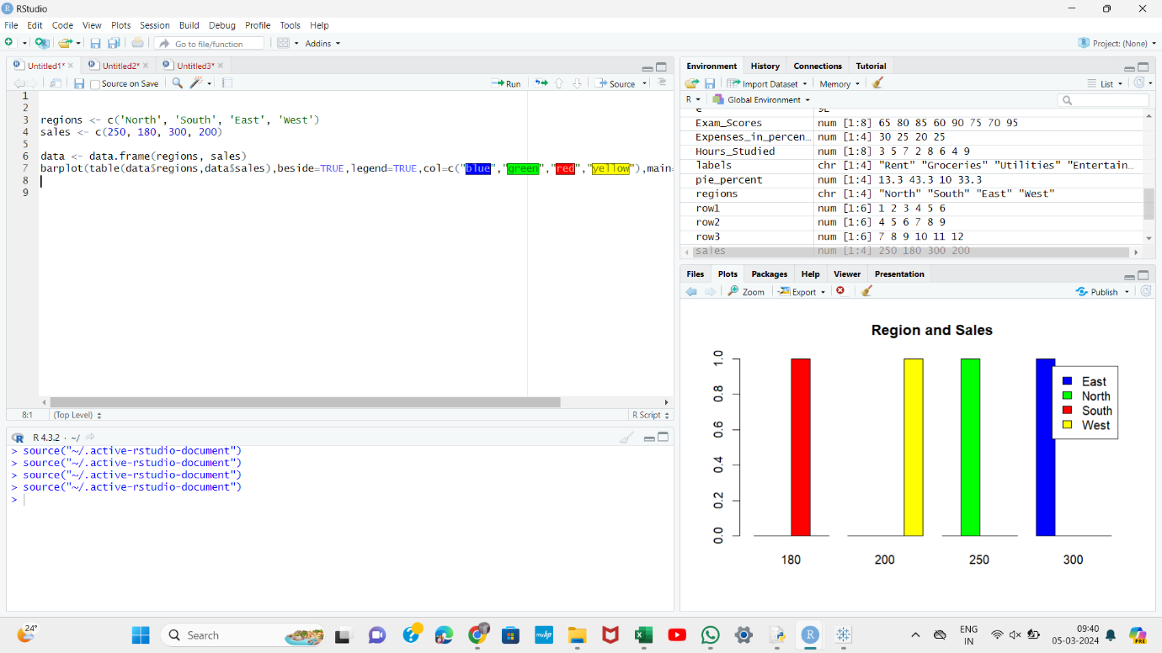

**Python**

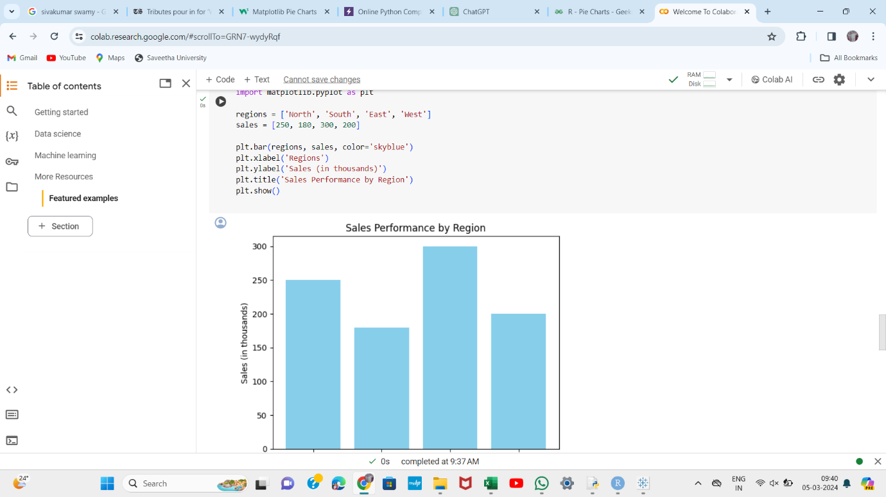

**Tableau**

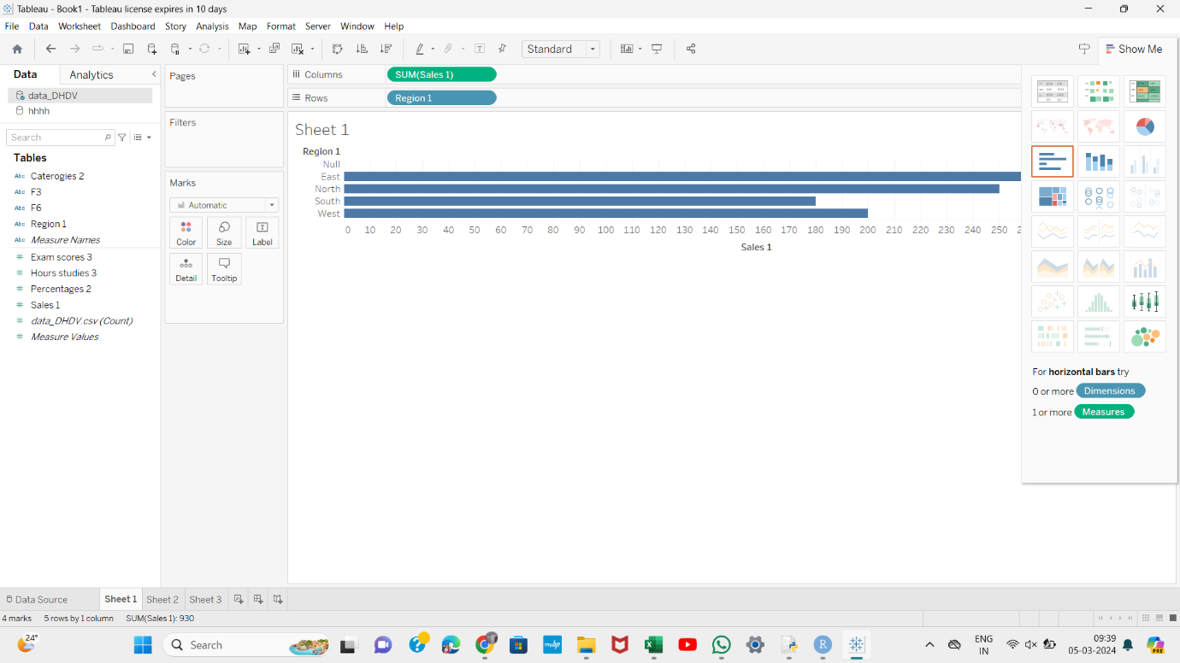

**Case Study 2** : Case study example for a pie chart data visualization using Python, R, and Tableau. Suppose we have a dataset representing the distribution of expenses in a household budget.

Dataset:

Categories: Rent, Groceries, Utilities, Entertainment

Expenses in percentages: [30, 25, 20, 25]

**R Programming**

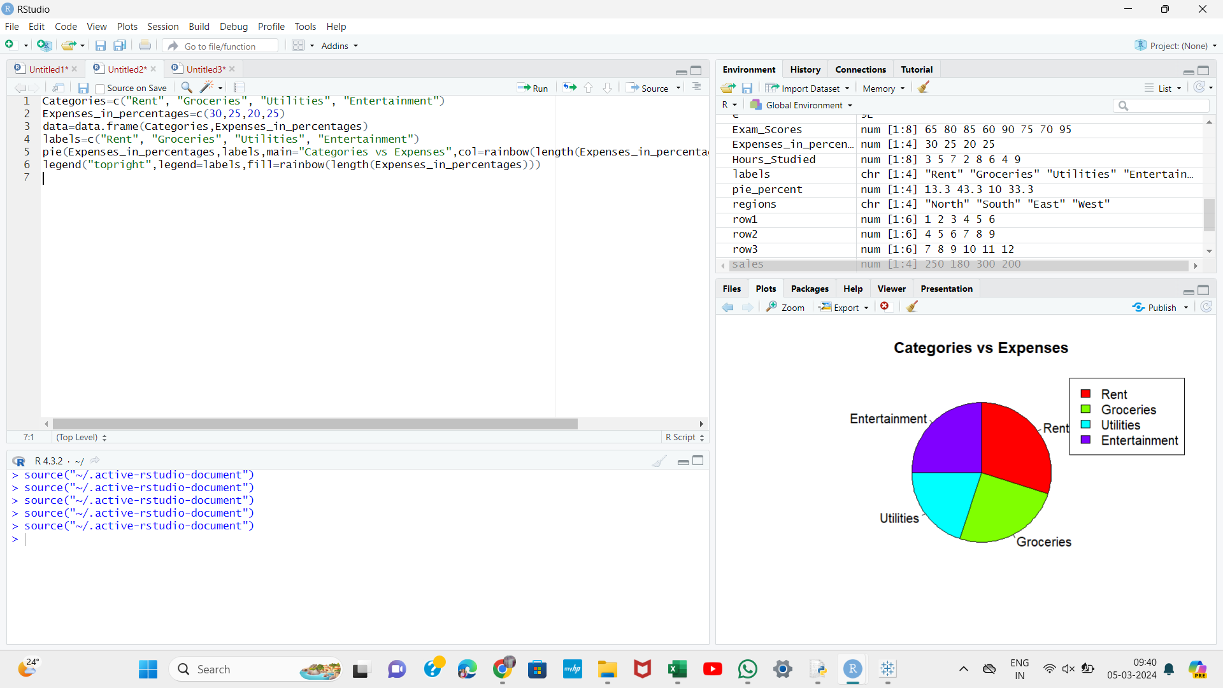

**Python**

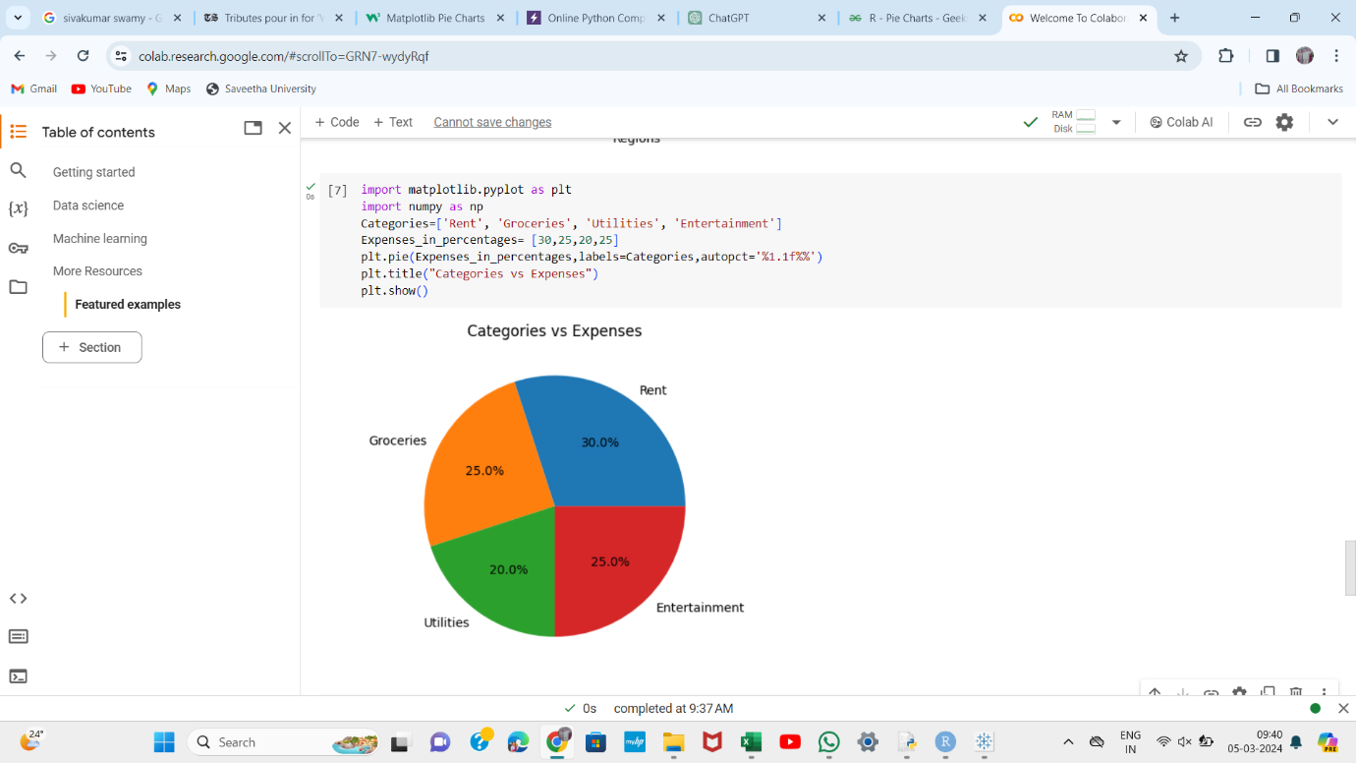

**Tableau**

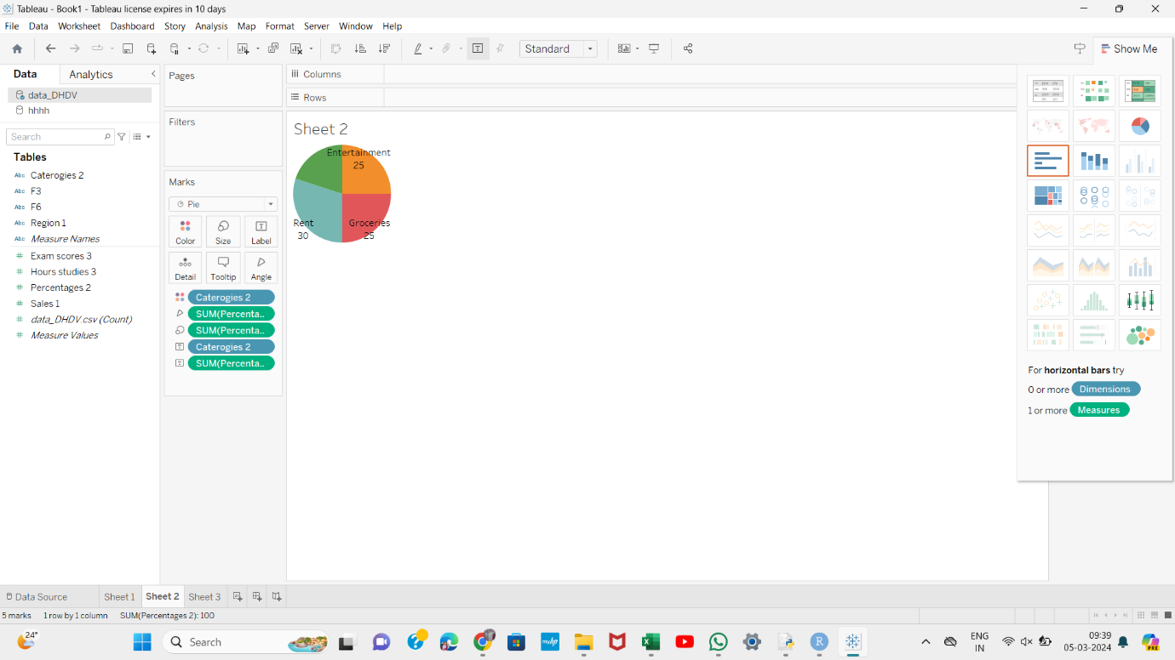

**Case Study 3** : Case study example for a scatter plot data visualization using Python, R, and Tableau. Suppose we have a dataset representing the relationship between the number of hours studied and exam scores for a group of students. Dataset:

Hours Studied: [3, 5, 7, 2, 8, 6, 4, 9]

Exam Scores: [65, 80, 85, 60, 90, 75, 70, 95]

**R Programming**

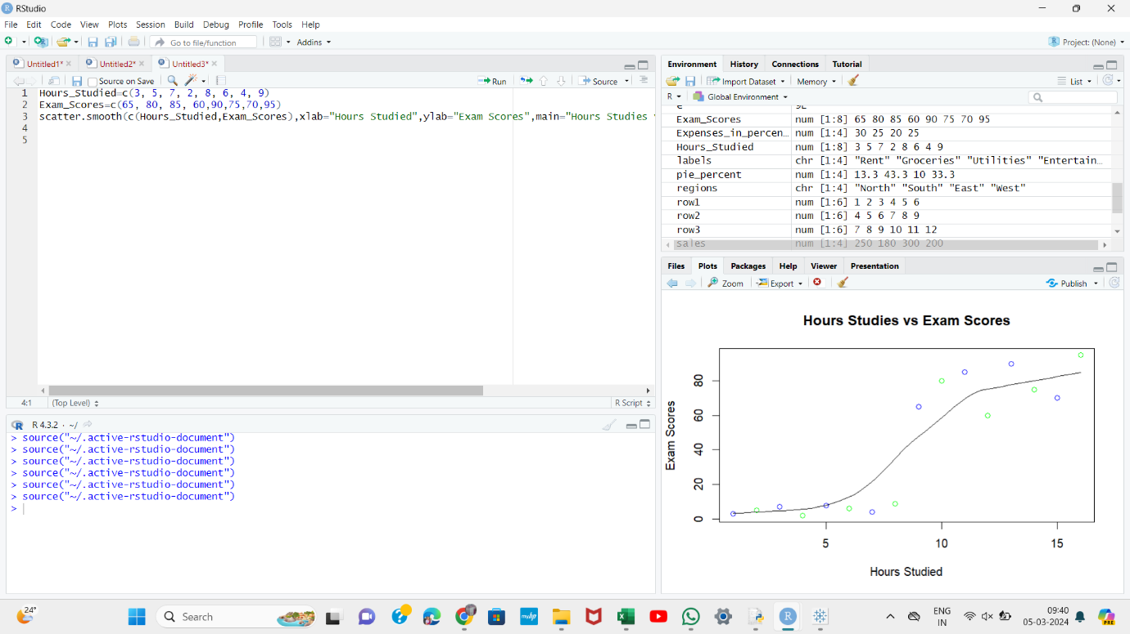

**Python**

